***%***Email your students to say hi and tell them to get on neurostars\*\*\****

***TA training videos*** [***folder***](https://drive.google.com/drive/u/0/folders/1pxqwONAbbNjHbXvUh1QKMV2oBckokElJ)

***To provide feedback on*** [***tutorials***](https://docs.google.com/document/d/1Mq51yKFSWjJ3fA9OXjAaAsQEL2_sBcwdkIZayG8Tp0g/edit?usp=sharing)

[**Python sign up**](https://docs.google.com/forms/d/e/1FAIpQLSeSTgsa8Vcqve7SwTy2S4RyUoKJTzK0NnIztZJzbPaCVG100Q/viewform)

**Carsen will not be answering any more emails unless they are related to zoom pro** - all your lead TAs have emailed you and they are your contact point! Also some of you have not activated your zoom accounts - please do that and send a link to your lead TA!

**Where is my neurostars invite!?**

1. Did you make an account in the past? If so you will not receive an invite, log in and see if you can see your pod.
2. Is this email in your spam/junk folder? (also check spam for your student assignment)
3. If they do not see the “all” drop-down menu (where the assigned pod should appear) next to “Neuromatch Academy”, this is because they used a different email to register. Ask them to sign outand register again using their NMA email address.

**Other useful resources:**

* [TA training slides](https://docs.google.com/presentation/d/1NJRbus0AJ_WzUigP9vSKNgfdp31CjFxkGyP7v3jltGA/edit#slide=id.g82335e49d8_77_4)
* [Zoom guide for TAs](https://docs.google.com/document/d/1VTnPA7dMwqpoE_Dl-jWL32g99P_ey4g-NmF7OEzhqR8/preview) (from code-in-place)
* [How-to-tutorial](https://docs.google.com/document/d/1znLhHKgC_TAia4vRTxQSV3-FV49W8ctBAT-Serex1Vc/edit?usp=sharing)
* 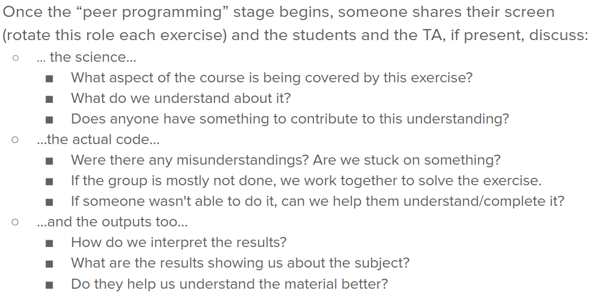
* Course feedback form will be sent individually on Thursday
* Make sure audio works [here](https://webcamera.io/) (please buy cheap headphone with mic if needed using the $1500 we are paying you with - we will not reimburse headphones)
* Sharing code website (optional, students will need to make accounts): <https://codeshare.io/>

**TA structure**

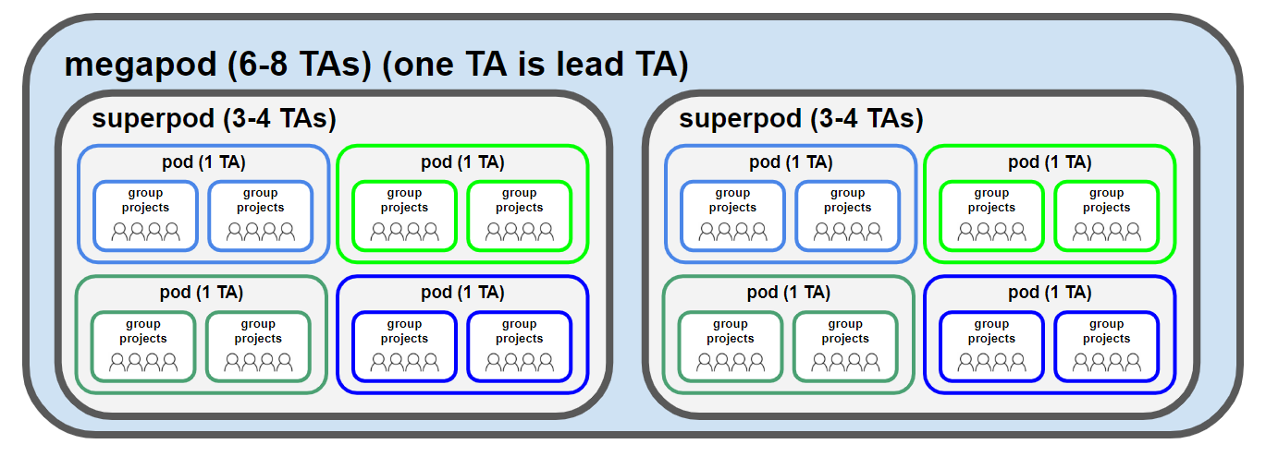

**TA financial information  
US non-resident:** Fill out W8BEN - there are some inputs that are country-specific, please consult someone at your institute for help or ask on slack (slack is currently being created)

**US F-1 visa holders**, you should have received an email from Megan, we can discuss this more in detail at zone 3 training session

**TA responsibilities**

**MAKE CALENDAR INVITES FOR YOUR ZOOM ROOM STARTING 15 MIN BEFORE TUTORIAL BLOCK** (first day 30 min before)

**1. Organizing your neurostars pod-specific category.**In a post please introduce yourself. See the example welcome post below and see this guide on how to make your [post](https://docs.google.com/document/d/1M0Qb_wLfN2Aul-BlA6JBZjhvr6kRTqa-OH5Od6ccGsE/edit). Please also make a post that provides the schedule info (as computed [here](https://colab.research.google.com/drive/1IfyXSrOwWtkEu5o9PYVwY6zbQ_9PGd8g)) and a zoom link for your room and the zoom link for your superpod (when available). We will provide an instructional video for this for Tuesday.

**2. Say hello to your pod via email and on the first day**

The 30 min keynote slot on the first day will be used to make sure everyone can get into zoom and say hello! Make sure your students watch the keynote the night before or earlier before that time slot. Have everyone introduce themselves and tell a little bit about their research interests. Use an ice-breaker like [this](https://www.mindsettlers.com/guide/42xoXdAepG4S4U8SiaA6Ii). An icebreaker with drawing ensures students have pen and paper too for going through tutorials :)

**3. Create an inclusive and respectful learning environment.**

Encourage students to work together to solve problems. Here’s a link to the [code of conduct](https://docs.google.com/document/d/1TF7Er5QVcej_OQde0vUq92G58hUX2MBEregc_jXVBhw).

**4. Taking attendance and acquiring feedback.**You will need to make an online-accessible spreadsheet (either in onedrive or google drive, see example [here](https://docs.google.com/spreadsheets/d/1m5bGlndm7CnKy0q2b8ejhxTWfC_s94uV_TJrZAYTe04/edit?usp=sharing)) that you fill out **daily** to take attendance for your pod. You need to share the link with your lead TA. You also need to make sure that students fill ou**t feedback forms each day so you can tell if they’ve found the material too easy or too hard.**

**5. Being present at all tutorial blocks.**

You need to tell your lead TA if you will not be available during the tutorial session.

**6. TA Q&A AKA “office hours” for students.**

If you are in a super-pod with 3 TAs you are responsible for being present during the office hours session 4-5 days during the course. If you are in a super-pod with 4 TAs you are responsible for 3-4 days.

**7. Advising students on projects.**

~30 minutes per group within your pod, twice a week. This will be < 1h hour per day. Ideally, if you can be ‘available’ for questions on the other days during the week for ~1h, you can treat it as ‘office hours’ answering questions only if groups come to you. You should focus primarily on coding help, but help ensure the projects seem to not be ‘stuck’ or ‘lost’. The students will self-organize for projects, but you will need to assist them in breaking into groups and choosing a topic during week one. After they have split into groups they should collaborate in their own zoom rooms or google meet or skype, and post these times and links in the neurostars channel. The project ideas are in the [Possible Projects](https://docs.google.com/presentation/d/1WAHfJcBPM4rmwwvreAAS92sRYtltJRwklxH-82NzCYo/edit?usp=sharing) slide deck. See the [NMA Project Plan](https://docs.google.com/document/d/1WMpVfY_-YCvzNzphS1KJOJ0RlIGar7DSP6_omyRE128/edit?usp=sharing) for more details.

Richard’s welcome post below includes a fun icebreaker :) also you can post gifs on neurostars!

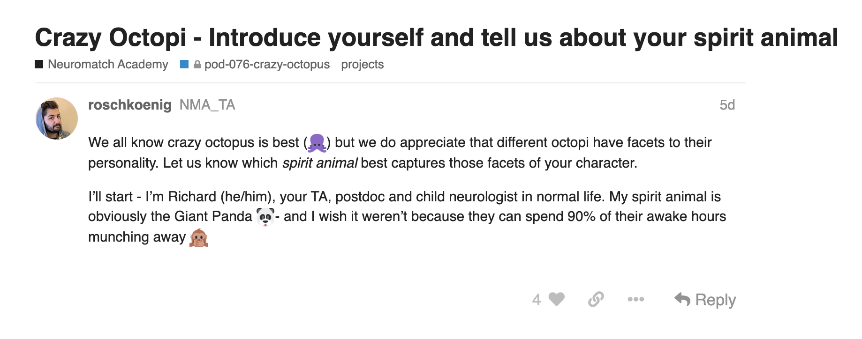

**TA daily checklist**

* Show up to your zoom room ~3-5 min before scheduled tutorial block
* Answer any questions for the first 15 min
* Assign students to breakout rooms randomly
* After first block of tutorials make sure to SET A TIME to return from break
* After second block of tutorials make sure students are ready for crowdcast / Q&A
* Take attendance
* Make sure students fill out feedback forms

**Lead TA specific duties**

**1. Dealing with TA absences.**

If a TA will miss 1-2 hours of a day, that is okay. Please coordinate with their super pod so that their students can join another group when going through the exercises. If a TA will miss an entire day and is zone 2 or 3, please contact me and I will see if our sub-TA is available to cover.

**2. Organizing TA Q&A**

Make sure that a schedule is established and that there is a TA at the super-pod TA Q&A.

**3. Making sure that students are learning**

You will also have access to the feedback form submissions, so you can tell if the students are learning. You can give advice to TAs to help them. See example [here](https://forms.office.com/Pages/ResponsePage.aspx?id=0MuK3YWtuU6KdocQJ61KG3aIKk4Le2dKm1ndx0LBPBVURFZWUDU3T0NTTVBRQUc3WVhYRkhJTEpWRy4u). We will make the forms and provide links.

**4. Being available before tutorials to advise TAs**

If TAs need help with a certain day of material before the day happens, they can ask questions during the 1 hour before the tutorials start. This will be held in TBD zoom rooms for each zone.

**5. Giving advice generally to TAs**

There is a TAs subcategory on neurostars. Please check it somewhat regularly to make sure that none of the TAs are confused.

Make feedback forms anonymous!!!

**General student questions you may receive (these will be on the website soon)**

**1. “I don’t speak the pod language, or I can’t make the timezone, or I can’t attend Neuromatch anymore.”**

Tell the student to email [pod@neuromatch.io](mailto:pod@neuromatch.io). Any requests to swap that are not related to language or timezone will *not* be granted.

**2. “I haven’t received an Interactive student payment email.“**

If you were accepted as an Interactive student but have not received information about your fee payment, please wait a few days for info about how to log into your student portal, where you'll see your fee and be able to pay online. We will have the information available in a few days, but the amount will not exceed 100USD and a fee waiver will be available for those who cannot have their fee covered by either their institution, company, or lab and cannot pay on their own. Thus, if you have been accepted into the Academy you are guaranteed to be able to participate regardless of your funding status! **Please note that we cannot accommodate direct payments from your university or company for your student fee. You can pay by credit card in the student portal and then be reimbursed according to your local policies.**

**3. “I need to be absent for some lessons/days.“**

The course content of the Academy is rigorous and cumulative which makes it difficult to keep up if you miss days in the middle. Therefore we expect Interactive students to be present for the whole 3 weeks of the program. However, if you need to be absent from the program for any amount of time, tell your TA ahead of time or as soon as possible if it is an emergency. Please also see the next item for the impact of absences on your certificate of completion/participation. TAs: talk to your lead TA about students who are requesting absences.

**4. Certificates of completion/participation.**

Students will receive a certificate of completion/participation at the end of the course, which will show how much of the course you completed. If you missed 1 day, it will say “93% completed”, if you missed 2 days it will say “86% completed”, and so on. This certificate will also say whether you successfully participated in your group project. We will be able to mention the name of your institution on the certificate (for example, Laura from the University of X). If you miss more than 50% of the course you will not receive a certificate of completion/participation.

**5. Refunds.**

Unfortunately we cannot process fee refunds once you have paid. We have hired the exact right number of TAs to accommodate all the registered Interactive students, and we can’t take back their stipends if you drop out!